 | METHODOLOGY  CLEANING | 

SCENARIO DETAILS
Asset Number | 4000260419, 4000260414, 4000260407, 4000260417, 4000260418, 4000260413, 4000268691, 4000260412, 4000260415, 4000260411, 4000260409, 4000260416, 4000260408, 4000260410
Model | Ecosol RSF 100 gully pit basket (Marked on the map as green dots)
Location | Broad Street and Marine Parade, Southport
Tidal / Other Influence | When cleaning the RSF 100’s Gully pit baskets there must be minimal disruptions to traffic flows, pedestrians, and surrounding shops
Unit Capacity | Removable and cleaning of 14 Ecosol RSF100 gully pit baskets

SITE PHOTOS
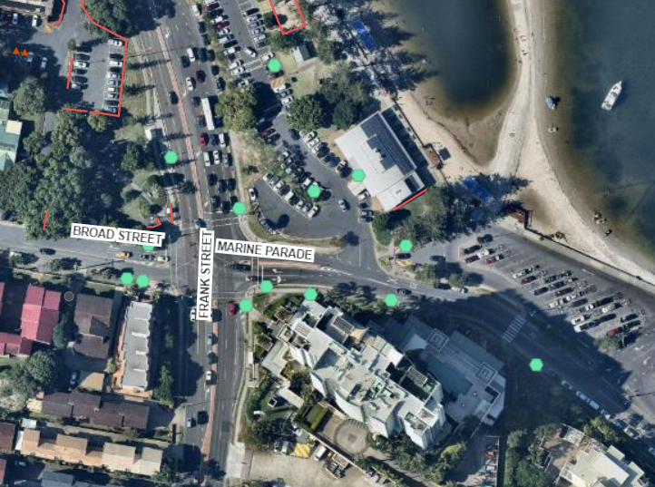  Aerial map of the Stormwater Ecosol RSF 100 gully pits locations. | 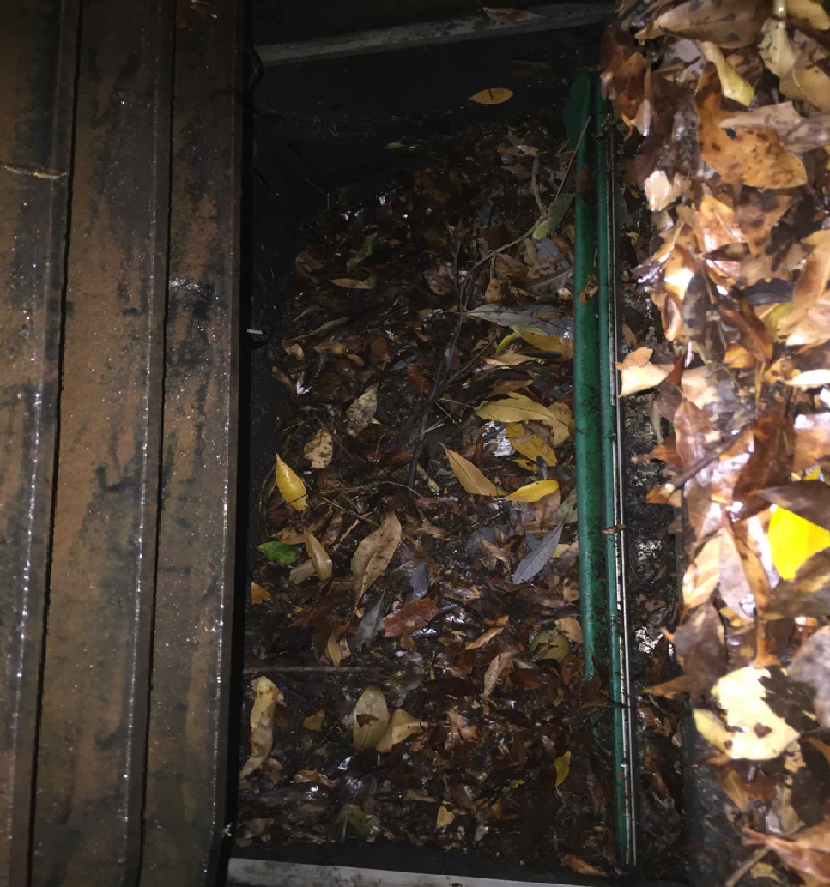  Example of an Ecosol RSF 100 gully pit basket full of contaminant and then empty of contaminant. | 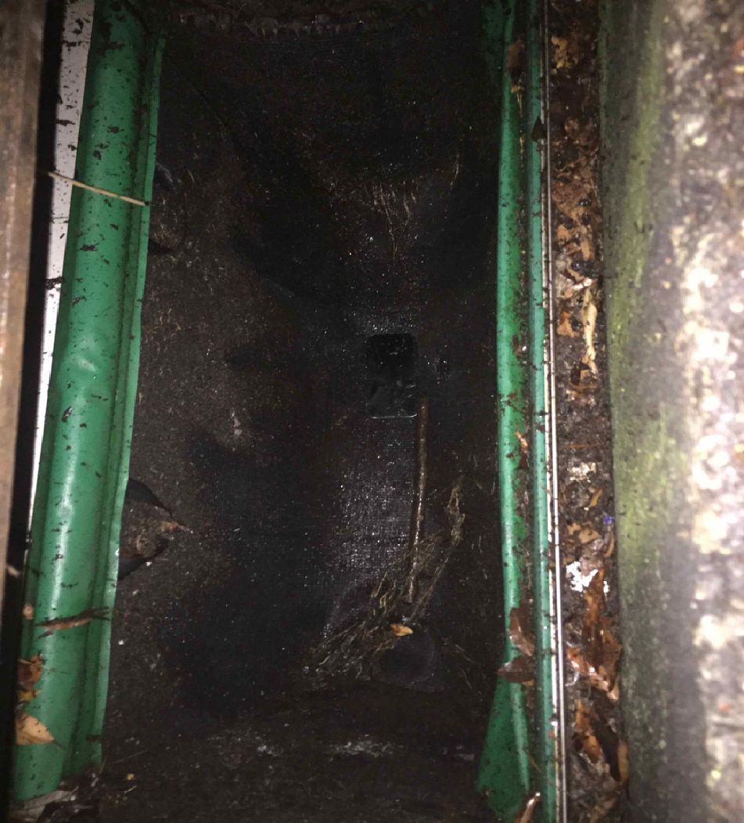

METHODOLOGY
Item | Description | Photo / Comments
1 | Site Establishment / Access Requirements
1.1 | Starting Night/early morning at approximately 4am (Or as permit allows).
1.2 | Cleaning of litter baskets conducted under mobile setup, travelling on the left hand side of the road, in accordance with traffic guidance scheme and permit allowable times (e.g. TMR and Council permit).
1.3 | Best to clean those gully pit RSF 100 litter basket located in the Charis Seafood and boat ramp carparks either after 8pm to avoid cars parking on gully pits and heavy pedestrian traffic and carpark use.
1.4 | Start works at 7pm to avoid peak hour traffic, however early enough to avoid noise pollution to nearby residents.
2 | Traffic and Pedestrian Management
2.1 | Traffic and pedestrian control will be required to ensure to manage passing traffic and pedestrians during works. Ensure appropriate traffic management plan and permits sourced prior to works.
2.2 | A Traffic Guidance Scheme (TGS) is to be procured to undertake litter basket cleans under a mobile setup. No more then 10- 20 mins stopping time per location, as per the Queensland Manual of Uniform Traffic Control Devices (MUTCD).
2.3 | Source permits for undertaking works from both TMR for Frank Street (Main Road) and the Council’s intersecting streets, being Broad Street and Marine Parade.
3 | Plant & Equipment Required
3.1 | Refer to the Resource Allocation table below.
4 | Tidal Influence
4.1 | There is a risk of tidal impacts on these assets as the downstream headworks discharge a short distance away from the Broadwater. There is no penstock valve to restrict backflow, therefore considerations must be made around the tides. Pits will submerge with tidal water during high tide levels, preventing the ability to vacuum remove pollutants effectively.
5 | WHS Obligations
5.1 | Safe Work Method Statement and Standard Operating Procedures. | Refer to SWMS / SOP
5.2 | Ensure all operators onsite have viewed the site specific SWMS and EMP and discuss the potential risks of the day during the pre-start meeting.
5.3 | Confined Space Entry - Not required.
5.4 | Working At Heights - Not required.
6 | Environmental Obligations
6.1 | Environmental Management Plan (EMP) below. | Refer to Site Specific EMP
7 | Cleaning Methodology
7.1 | Arrive Onsite at approximately 7pm (Or as permit allows).  Set up truck/towing vehicle with trailer mounted vacuum loader and high pressure hose (e.g. Vermeer VX30-250).  Vehicle and plant to sit parallel with road/street shoulder.  Vehicles to incorporate flashing lights and beacons.
7.2 | Traffic controller/s to set up mobile traffic control, including mobile utility with traffic cones and signage to divert traffic and pedestrians in accordance with Traffic Guidance Scheme (TGS).
7.3 | Tow and position the trailer mounted vacuum loader in front of the first gully pit.
7.4 | Safely open gully pit grate by hand (wearing gloves).
Take photographs of the RSF 100 litter basket before any clean is undertaken.
Record volume of pollutants retained (%) within the litter basket and the approximate breakdown of pollutants to be removed (e.g. litter, vegetation, and sediment) into the Clean Report.
7.5 | Lower the vacuum hose into the RSF100 filter basket and remove waste by vacuum.
7.6 | Wash down and vacuum the apron area and grate of the gully pit removing any build up of pollutants before they enter the gully pit, and from the kerb.
7.7 | High pressure hose the bypass flaps, steel frame and filter basket of the RSF 100 litter basket to remove any grit and debris.
7.8 | Inspect all other basket components for operation and condition (e.g. awning mould damage preventing litter basket filter bag to be affixed into frame appropriately).  Ensure the bypass flap is operational and in good condition (e.g. no splitting).
7.9 | Record any damage or defects found into the Clean Report, for future repair.
7.10 | Inspect gully pit base for any vacuum removal of pollutants beneath litter basket.
7.11 | If a build up of pollutant have been identified beneath the basket, remove the filter basket by hand, using the appropriate handles on the filter basket. Vacuum load any build up of pollutants for removal and ensure gully pit outlet pipes are free from blockage.
7.12 | Replace filter basket into frame and ensure it is affixed and secured for operation.
7.13 | Safely close the gully pit grate, by hand (ensuring to wear gloves).
7.14 | Secure hoses onto trailer mounted vacuum loader.
 | Drive to next gully pit for cleaning of litter basket. Repeat process above, until all baskets are cleaned.
7.15 | Ensure to remove all traffic and pedestrian controls once cleaned.
8 | Timing
8.1 | Start Time: ____7pm____ (Approx.)
8.2 | Finish Time: _____8:30pm___ (Approx.)
83 | Total Duration (hrs): ___1.5_____ (Approx.)

RESOURCES ALLOCATION — PLANT & EQUIPMENT
Item | Description | No. Proposed
1 | Small Truck/Vehicle - Suitable to tow up to 3.5T trailer. | 1
2 | Trailer Mounted Combination Vacuum Loader with High Pressure Hose system (3000PSi) | 1
3 | Hand tools (Inclu. Shovel, hammer, screwdriver, PPE, gloves, etc) | 1
4 | Traffic Management Equipment (incl. cones, signage) | Mobile Setup (Ute)

RESOURCES ALLOCATION — PERSONNEL
Item | Position | Associated Skill Set | No. Proposed
1 | Operator | SOP of Trailer Mounted Vacuum Loader and High Pressure Hose | 2
2 | Traffic Controller | Traffic Controller Certified | 2

ENVIRONMENTAL MANAGEMENT PLAN (EMP)
Item | Environmental Risk | Control Measures | Monitoring & Verification | Responsibility
1
2
3
4
5
6
7
8

