 | METHODOLOGY  CLEANING | 

SCENARIO DETAILS
Asset Number | 4000010069
Model | CDS3018
Location | Appel Park, Ferny Ave, Surfers Paradise, QLD
Tidal / Other Influence | Assume low tide at the Seaway of 0.23m, outlet permanently submerged. Clear weather.
Unit Capacity | Removable Basket 75% full, 400mm sediment within screening chamber.

SITE PHOTOS
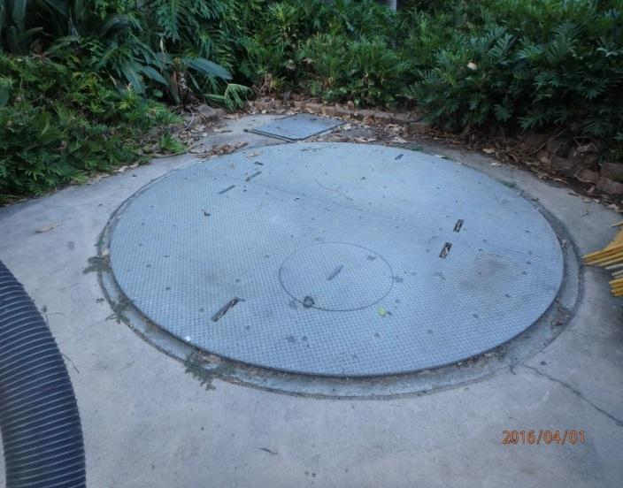  GPT Access Cover | 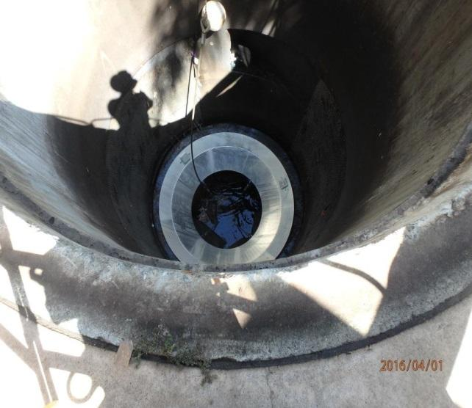  GPT Capture Chamber and Sump, with Removable Basket

METHODOLOGY
Item | Description | Photo / Comments
1 | Site Establishment / Access Requirements
1.1 | Refer to site works layout below.
1.2 | Hard stand access is available onsite utilising footpath and access in kerb.  Hard stand access available adjacent GPT for Crane Truck to be parked, ready for use.
1.3 | Kerbside shoulder (Ferny Ave) available adjacent site for temporary parking and movement of vehicles.
2 | Traffic and Pedestrian Management
2.1 | Traffic and pedestrian control will be required to ensure safe entrance and exit of the vacuum truck/vehicles and to manage passing traffic and pedestrians during works. Ensure appropriate traffic management plan and permits sourced prior to works.
2.2 | Due to the size and location of this GPT, an exclusion zone around the asset must be established with temporary fencing to prohibit pedestrian/civilian access.
3 | Plant & Equipment Required
3.1 | Refer to the Resource Allocation table below.
4 | Tidal Influence
4.1 | The outlet is permanently submerged by tidal impacts on this asset as the downstream headwall discharges into Nerang River/Waterway. There is a tide gate valve on the outlet to help restrict backflow. Ensure all confined space works are undertaken during the peak low period.
4.2 | Book works to occur during nightworks at lowest tide level. Best to look at starting works when tide is dropping, providing at least a 5 hour window of low tide. In this scenario we are working to a 0.23m tide level, whereby there will be approximately 300mm of water within the outlet pipeline and partial submergence of GPT diversion chamber floor. This would normally be scheduled at a lower tide level, as tides permit.
5 | WHS Obligations
5.1 | Safe Work Method Statement and Standard Operating Procedures. | Refer to SWMS / SOP
5.2 | Ensure all operators onsite have viewed the site specific SWMS and EMP and discuss the potential risks of the day during the pre-start meeting.
5.3 | Confined Space Entry - If required, ensure to source CSE Permit and conduct CSE with appropriate risk assessment, entry/exit log and CSE equipment, including gas detector, harness and tripod.
5.4 | Working At Heights - Prior to removing the access covers, ensure all operators working around the open edge are wearing their fall arrest equipment, including a harness and extendable lanyard, connected to certified anchor points (e.g. on truck).
6 | Environmental Obligations
6.1 | Environmental Management Plan (EMP) below. | Refer to Site Specific EMP
7 | Cleaning Methodology
7.1 | Arrive Onsite at approximately 10pm. Park Crane Truck parallel with the GPT within provided hardstand space.
7.2 | Traffic control to set up traffic control, including traffic cones, signage and pedestrian controls around parked vehicles and sites to divert traffic and pedestrians in accordance with the Traffic Guidance Scheme. Traffic management plan classed as low impact.
7.3 | Deliver and set up temporary fencing around Appel Park side of GPT to isolate the area.
7.4 | Park and position Hook Truck with sealed waste bin, within the kerbside shoulder on Ferny Ave, parallel with footpath.
7.5 | Setup and affix containment boom across outlet, in front of tide gate valve. This is to act as containment in the event of any minor spills that could discharge downstream from the GPT cleaning activities.
7.6 | Using gatic lifters and socket set, to open steel (Chequer Plate) access covers to both the inlet and outlet diversion chamber.
7.7 | Inspect condition of chamber and isolation/penstock valves.
7.8 | Close both inlet and outlet isolation valves using Crane Truck lift boom. Ensure chains are suitably rated to undertake lifting task.
7.9 | Under confined space entry requirements (e.g. permit, risk assessment and entry/exit log), enter GPT diversion chamber and ensure penstock/isolation valves are secured and sealed. Use sandbags to seal around base of each penstock/isolation valve to ensure seal. Use materials winch (tridpod) to lower sandbags into confined space.
7.10 | Ensure all workers within the isolated area, with a risk of falling, are to wear a harness and connected via a lanyard to certified anchor points for fall arrest and protection. No other worker should be within 2m of GPT capture chamber opening.
7.11 | Mark up alignment of the two (x2) steel GPT capture chamber access cover sections for ease of realignment. Lift steel access cover sections from top of GPT capture chamber. Two part section lift. And position both sections onto ground out of the way from the GPT capture chamber opening, still within the isolated area.
7.12 | Undertake a visual inspection of the capture chamber and retained pollutants, to determine levels of any potential hydrocarbons or other irregular contaminants.
7.13 | Take photographs of capture chamber and retained pollutants, inside the diversion chamber areas, including whole of site and outlets downstream.
7.14 | Take measurement of surface level to top of pollutants, retained in the GPT capture chamber to record depth to pollutants within required reporting.
7.15 | Observe submerged sump. If hydrocarbons are present, ensure they are decanted prior to dewatering and disposed of at an approved facility.
7.16 | Using crane truck and boom, position boom over GPT capture chamber and connect GPT basket lift cable to appropriate lifting points on crane truck boom. Ensure chains are suitably rated to undertake lifting task. Worker to use hook pole to grab lift cable for connection.
7.17 | Lift basket to approximately level with surface level, and allow basket to drainage until excess water has drained back into the GPT capture chamber sump and the basket weight reaches a reduced and safe lift weight.
7.18 | Lift basket and position over hook bin. Unlock teathers/pins holding basket flap in closed position to allow the retained pollutants wihtin the basket to spill, carefully, into the hook bin.
7.19 | Once emptied and suspended over hook bin. Wash down basket using truck hose to clean. Once cleaned, inspect basket to ensure there is no damage or defects (e.g. tears, corroded locking teathers/pins. Report within Clean Report accordingly. Close up basket flap and relock pins to close basket.
7.20 | Position basket onto ground, out of way of GPT capture chamber opening. Disconnect lift cable and position boom back onto Crane Truck out of the way.
7.21 | Check sacrificial anodes and replace as required. Inspect lifting arrangement and cable swages for corrosion. Report into Clean Report accordingly.
7.22 | The hook truck will then seal hook bin shut and leave site to dispose of the removed pollutants at an approved waste disposal facility.
7.23 | Connect the lift boom of Crane Truck to 4inch dewatering pump, lift and lower pump head into GPT sump. The pump remains on the back of the Crane Truck.
7.24 | Pump excess water from above the GPT sump (being careful not to disturb or remove the 400mm of sediment within the sump) into the isolated inlet side of the diversion chamber through the inlet chamber access opening.
7.25 | Ensure a compliant dewatering bag is used on the outlet of the pump hose, to ensure any potential contaminates/pollutants and suspended solids are captured during the dewatering process.
7.26 | Once the GPT capture chamber is dewatered to top of sump and sediment (400mm depth), park the vacuum combination truck behind the crane truck.
7.27 | Using the 6inch retractable boom of the vacuum combination truck, position the vacuum hose over the GPT capture chamber opening and direct the hose into the sump for vacuum removal of the sediment and retained pollutants/sludge within the sump.
7.28 | Use a high volume hose to assist with the vacuum removal of pollutants, ensuring all areas of the chamber, including the GPT screens are free from debris.
7.29 | Report on breakdown of pollutants (e.g. Litter, Vegetation, Silt/Sediment volumes) within Clean Report.
7.30 | Note: Have secondary vacuum truck on standby, nearby for any requirement to remove and transport excess pollutant volumes.
7.31 | Check behind screens through the screens to determine if any excess or captured pollutants (e.g. vegetation/silt) are present. Report any build up of pollutants behind the screens within Clean Report for future removal works. Any identified high levels of pollutant build up behind the GPT screens would trigger the action of confined space entry activities, the removal of the screens, and removal of the built up pollutants. Screens would be replaced once pollutants removed.
7.32 | Check inlet to GPT capture chamber is free of pollutants or debris.
7.33 | Once GPT capture chamber is completely cleaned. Inspect all areas of the chamber, sump and screens for any damage or defects, and report accordingly within the Clean report. Take photos of report.
7.34 | Remove vacuum hose by retracting vacuum hose boom.
7.35 | Insert the vacuum hose into the inlet chamber and remove any build up of pollutants from the inlet area of the diversion chamber. Repeat for the outlet chamber, where necessary, ensuring to prevent any flows from escaping downstream by use of vacuum hose.
7.36 | Once all pollutants are removed and all areas are cleaned, remove and pack up vacuum hose using retractable boom. Seal vacuum truck.
7.37 | Reposition Crane Truck lift boom over GPT basket. Reconnect basket lift cable. Lift basket and position over the GPT capture chamber and sump. Lower and reposition basket and collar into place. Disconnect lift cable using hook pole and retract boom.
7.38 | Connect Crane Truck boom to lift GPT capture chamber steel access cover sections (x2) and lift each into position. Inspect all components of the steel access cover sections prior to dropping and repositioning. Use previous markings to realign steel access cover sections. Ensure both sections sit flush with surface level of the footpath to avoid any tripping hazards and to ensure they are fully supported by concrete rebate.
7.39 | Ensure both isolation valves (penstock valves) within the inlet and outlet areas of the diversion chamber are fully opened. Inspect their condition and report accordingly, ensuring no defects or damage.
7.40 | Using gatic lifters, grease and close the cast iron access covers to the diversion chamber.
7.41 | Once all access openings have been closed and locked, remove all plant, equipment, materials and rubbish. Wash down entire isolated work area using volume hose.
7.42 | Apply sealant to gaps around the two section GPT steel access covers and inspect all covers, including penstock spigot access covers to ensure no are no tripping hazards.
7.43 | Remove all and load all temp fencing.
7.44 | Remove all traffic and pedestrian controls.
8 | Timing
8.1 | Start Time: ____10pm____ (Approx.)
8.2 | Finish Time: _____3am___ (Approx.)
8.3 | Total Duration (hrs): ___5_____ (Approx.)
9 | Environmental Incident Reponse
9.1 | While cleaning the above unit, hydrocarbons have been noticed to be present downstream of the GPT and have been released into the Nerang River.
9.2 | Report spill event to Council Contract Supervisor immediately.
9.3 | Ensure the containment boom installed across outlet at headwall is secured and containing spill.
9.4 | Use the spill response kit to deploy floating absorbent booms and pads into the contained area.
9.5 | Monitor containment of spill to ensure that no leaks are found to be escaping the containment boom.
9.6 | Call in response vacuum truck to enter downstream area, via park, to remove contained spill via vacuum removal (Skimming top of water). Ensure the truck is guided through park with spotter to avoid damage to pits or overhead obstacles (e.g. trees and lighting).
9.7 | Ensure vacuum truck and activities are isolated and pedestrians are diverted around work activities using traffic/pedestrian control.

RESOURCES ALLOCATION — PLANT & EQUIPMENT
Item | Description | No. Proposed
1 | Crane Truck with Hiab | 1
2 | Combination Drain Cleaning Unit | 1
3 | Dewatering pump | 1
4 | Filtration/ Dewatering bladder/bag | 1
5 | Hook Truck, with sealed bin. | 1
6 | Traffic Management Equipment (incl. cones, signage) | Set
7 | Temporary Fencing | 12 x Sections
8 | Containment Boom (Approx. 15m) | 1 (Approx. 15m L section)
9 | Sandbags | 20
10 | Fall Arrest Equipment (incl. Harness, extendable lanyards) | 1 Set
11 | Confined Space Equipment (incl. Gas Detector, harness, lanyard, tripod) | 1 Set
12 | Isolation/Penstock valve keys | 1
13 | Hand tools (Incl. Gatic Lifters and Socket set) | 1 Set
14 | Spill Response Kit (Incl. absorbent booms and pads) | 1 Set

RESOURCES ALLOCATION — PERSONNEL
Item | Position | Associated Skill Set | No. Proposed
1 | Site Supervisor | Confined Space Entry, Working at Heights, Traffic Management | 1
2 | Senior Operator | Crane Operator (Licenced), Confined Space Entry, Working at Heights | 1
3 | Operator | Confined Space Entry, Working at Heights | 2
4 | Traffic Controller | Traffic Controller Certified | 2
5 | Truck Driver | HC Licence, Waste Transport | 1

ENVIRONMENTAL MANAGEMENT PLAN (EMP)
Item | Environmental Risk | Control Measures | Monitoring & Verification | Responsibility
1
2
3
4
5
6
7
8

